1. SCOPE
This standard applies to breadfruit flour, as defined in Section 2 below, which is used as a food or food ingredient. This standard does not apply to breadfruit only, other breadfruit products from fruit, leaves, bark or flowers, or breadfruit products for medicinal purposes.
2. DESCRIPTION
2.1 Product definition
The breadfruit flour is the flour that is derived from the milling of dry pulp of breadfruit plants, Artocarpus altilis of the Moraceae family.
Varieties
The South Pacific Commission published the results of a breadfruit survey in 1966, describing 166 named sorts from Tonga, Niue, Western and American Samoa, Papua and New Guinea, New Hebrides and Rotuma. There are 70 named varieties of seeded and seedless breadfruits in Fiji.
Varieties are locally separated into 8 classes by leaf form. The most used cultivar is “Ma’afala”
- ʻUlu Maoli (Hawaiian ʻulu): The original variety introduced to Hawaiʻi, known for its traditional significance and widespread presence.
- Ma’afala: A Samoan/Tongan variety, compact and prolific, with creamy, pale yellow flesh; now widely propagated via tissue culture.
- Otea: A fast-growing, Tahitian variety producing large, seedless fruits with firm, tender texture and pale yellow flesh; highly productive.
- Ulu Fiti: A Fijian variety, seeded, tender, and moist with a sweet flavor when ripe.
- Puou: A large, round fruit with slightly raised skin segments and a “collar” around the stem; more disease-prone than others.
- Lipet: A Micronesian variety known for large fruits, with some reaching nearly 11 lb; highly valued for yield.
2.2 Breadfruit
Fresh, firm and mature to ripe fruit, with white to yellow, is harvested, washed and dry. Fruit that is over-ripe, fallen, green, bruised and/or damaged, or containing foreign materials such as sticks, stem, leaves, bark and root material should be rejected and not be used in the production of breadfruit flour.
2.3 Production of breadfruit flour
Mature fruits are harvested. Washed breadfruits are peeled, and the pulp is sectioned, blanched, and then dried. Dried pulp is ground in a mill to produce flour that passed through a sieve.
3. ESSENTIAL COMPOSITION AND QUALITY FACTORS (More data on fruit than on flour)
To the extent possible, breadfruit flour shall be free from objectionable matter (e.g. leaves, seed fragments, fruit skin fragments, stems, insects, etc.) and according to good manufacturing practice.
Breadfruit flour shall be:
• free of leaves, bark, and/or stems;
• free from chilling injury;
• have no intentional adulteration;
• practically free from pests;
• practically free from damage caused by pests;
• free of visible mould;
• free from soil and foreign materials; and
• free from foreign odour.

4. FOOD ADDITIVES
No additives are permitted in the product as defined by the scope.
5. CONTAMINANTS
The products covered by this standard shall comply with the maximum levels for contaminants that are specified for the product in the General Standard for Contaminants and Toxins in Food and Feed (CXS 193- 1985), and the maximum residue limits for pesticides established by the Codex Alimentarius Commission.
6. HYGIENE
It is recommended that the products covered by the provisions of this standard be prepared and handled in accordance with appropriate sections of the General Principles of Food Hygiene (CXC 1-1969), and other relevant Codex texts such as codes of hygienic practice and codes of practice. The product should also comply with any microbiological criteria established in accordance with the Principles and Guidelines for the Establishment and Application of Microbiological Criteria Related to Foods (CXG 21- 1997).
7. PACKAGING
The breadfruit flour must be packed in containers that safeguard the hygienic, and organoleptic quality. The materials used for packaging must be new (for the purposes of this standard, this includes recycled material of food-grade quality.) The containers shall meet the quality, hygiene, ventilation and resistance characteristics to ensure suitable handling, shipping and preserving of the flour. Packages must be free of all foreign matter and smell.
8. LABELLING
The products shall be labelled in accordance with the General Standard for the Labelling of Pre-packaged Food (CXS 1-1985).
8.1 Name of the product
The name of the food product shall be “breadfruit flour”. The term “breadfruit flour” may be replaced by a term which has customarily been used to describe the product in the country in which the product is intended to be sold (e.g. “Ma’afala” flour).
8.2 Labelling on non-retail containers
The labelling of non-retail containers should be in accordance with the General Standard for the Labelling of Non-Retail Containers of Foods (CXS 346-2021).
9. METHODS OF ANALYSIS AND SAMPLING
For checking the compliance with this standard, the methods of analysis and sampling contained in the Recommended Methods of Analysis and Sampling (CXS 234-1999)6 relevant to the provisions in this standard, shall be used.

Other information
Fruits cannot be kept under 12C (chilling injury)
There is limited research looking at optimal processing methods to reduce the anti-nutritional contents present in breadfruit
Most varieties of breadfruit are purgative if eaten raw. Some varieties are boiled twice and the water thrown away, to avoid unpleasant effects, while there are a few named cultivars that can be safely eaten without cooking.
The cyclopropane-containing sterol, cycloartenol, has been isolated from the fresh fruit. It contitutes 12% of the non-saponifiable extract.
Breadfruit protein contains all of the essential amino acids and is especially rich in phenylalanine, leucine, isoleucine and valine
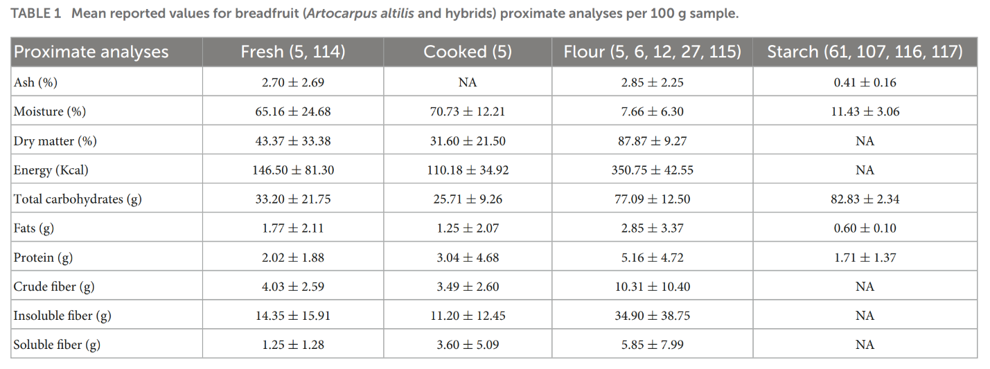
(Mehat et al., 2023)
