[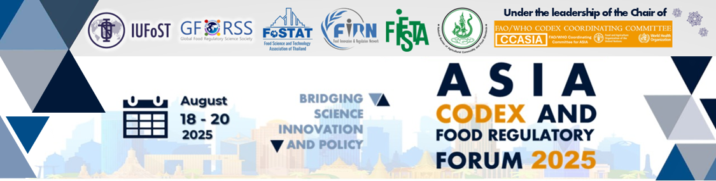](https://gforss.org/2025/07/11/2025asiacodexforum/)

**GROUP DISCUSSION • 20 AUGUST 2025**

**Formulation of Future Directions for the Management of Food Contact Materials (FCM) – Towards Regional Convergence and Role of Codex**

# Background

This questionnaire was developed to guide group discussions among CCASIA members and regional food stakeholders with the aim to identify future actions that CCASIA can recommend to Codex for better guidance and oversight of Food Contact Materials (FCMs), with emphasis on feasible approaches of food regulatory cooperation.

## Section 1: Regional Priorities and Common Needs

1. **Shared Regulatory Gaps**  
   Based on the discussion paper, which of the following are most urgent to address at the regional level in Asia to ensure better FCM oversight and alignment? (Select top 3)  
    Lack of harmonized migration testing conditions  
    No common documentation/Documentation of Compliance (DoC) format  
    Gaps in NIAS screening and risk assessment methods  
    Inconsistent oversight of recycled materials  
    Fragmented exposure assumptions  
    Other:

|  |
| --- |
| Click or tap here to enter text. |

1. **Priority Areas for Regional Alignment and Codex Input**  
   What are the areas where CCASIA countries can most meaningfully align and contribute to Codex work?  
   ☐ Shared definitions and horizontal safety objectives  
   ☐ Joint approach to GMP and documentation practices  
   ☐ Regional input to NIAS methodology  
   ☐ Technical consensus on recycled material requirements  
   ☐ Pilot contribution to “Codex-cleared application” list  
   ☐ Other:

|  |
| --- |
| Click or tap here to enter text. |

## Section 2: Operationalizing Stronger Codex Guidance for the Management of FCM: Roles, Pathways, and Leadership

1. How would a phased approach according to Option C proposed in the discussion paper be operationalized:   
   Phased approach includes:

* Step 1: Commission a full discussion paper and circulate a Circular Letter (CL) to map frameworks (2025)
* Step 2: Convene an FAO/WHO expert meeting to develop baseline methods for NIAS and testing (2026)
* Step 3: Launch an Ad Hoc Task Force to draft guidelines, recycled materials guidance, and pilot a cleared applications list (2027–2029)

How can CCASIA contribute to enabling this pathway? (Select all that apply)  
 Propose a regional contribution to the Codex discussion paper (e.g., regional gap analysis or position paper)  
 Encourage Member responses to the CL with regional coordination  
 Nominate regional experts to contribute to FAO/WHO meetings  
 Propose leadership or co-hosting of the Task Force by a CCASIA country  
 Support identification of pilot applications for the cleared list from the region  
 Other:

|  |
| --- |
| Click or tap here to enter text. |

1. **Leadership and Coordination:** To deliver the Phased Approach effectively, what type of leadership is required at each stage?

|  |  |
| --- | --- |
| Phase | Who should lead or co-lead this work? (mark and/or specify) |
| Mapping & Discussion Paper  (2025) | CCASIA Coordinator A volunteer country (specify): Click or tap here to enter text. |
| Expert Meeting  (2026) | FAO/WHO  Regional expert group  Host country from CCASIA:Click or tap here to enter text.  Other: Click or tap here to enter text. |
| Task Force Phase  (2027–2029) | Codex Commission  CCASIA member country (please propose): Click or tap here to enter text. Co-lead with non-Asia country (specify): Click or tap here to enter text. |

1. **Readiness for Involvement**: Would your country or institution consider taking a leadership role or technical contribution to any of these phases (discussion paper, expert meeting, task force)?  
    Yes, please indicate preferred area(s): Click or tap here to enter text.  
    Not at this time  
    Possibly, pending internal consultations
2. **Operational Enablers**: In your view, what mechanisms are needed to make the phased approach proposed in the discussion paper successful? (Choose top 2)  
    Dedicated financial support or trust fund  
    Technical secretariat hosted by a volunteering country  
    Regional expert group under CCASIA  
    Transparent data-sharing platform  
    Involvement of reference labs and academic partners  
    Formal engagement of industry observers  
    Other: Click or tap here to enter text.