[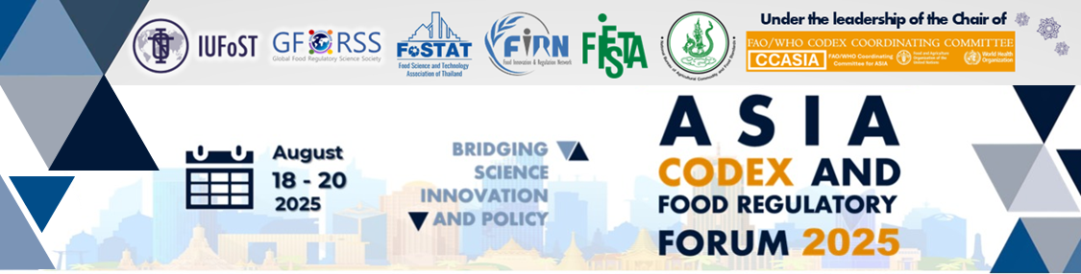](https://gforss.org/2025/07/11/2025asiacodexforum/)

**GROUP DISCUSSION • 19 AUGUST 2025**

**Advancing Agile Regulatory Models for Innovation Frameworks Addressing Innovation in Food Ingredients and Processes – Role of Codex**

# Background

This draft questionnaire was developed to guide group discussions among CCASIA members and regional food stakeholders with the aim to identify collaborative mechanisms that can **accelerate market access for innovative ingredients and processes**, while laying the groundwork for harmonization efforts that align with Codex principles.

### Section A: National Experience and Innovation Landscape

1. What types of **novel food products** or processes are currently under development or being commercialized in your country (e.g., cell-based meat, precision fermentation, high-pressure processing)?

* Please list 2–3 examples.

|  |
| --- |
| Click or tap here to enter text. |

* Are these products intended for domestic consumption, export, or both?

|  |
| --- |
| Click or tap here to enter text. |

1. Does your country have a formal definition for “novel food” or “novel process”?

Yes  No  In development

If yes, how is “novelty” determined (e.g., based on history of consumption, method of production, new ingredient functionality)?

|  |
| --- |
| Click or tap here to enter text. |

1. A. What are the main regulatory pathways available in your country for the approval of novel foods and ingredients?

|  |
| --- |
| Click or tap here to enter text. |

B. Are pre-market safety assessments required?

|  |
| --- |
| Click or tap here to enter text. |

C. Is there a mechanism for public consultation or stakeholder input?

|  |
| --- |
| Click or tap here to enter text. |

**Section B: Challenges and Needs**

1. What are the key regulatory or scientific challenges you know your jurisdiction faces in assessing or authorizing novel foods?

Lack of clear guidance or criteria

Limited capacity for safety assessments

Data gaps (e.g., toxicology, allergenicity, bioavailability)

Absence of international reference standards

Others (please specify):

|  |
| --- |
| Click or tap here to enter text. |

1. What kinds of support or collaboration would help address these challenges?

Access to shared safety data or regional dossiers

Joint reviews or expert committees

Regional guidance documents

Regulatory training and capacity building

Other:

|  |
| --- |
| Click or tap here to enter text. |

**Section C: Regional Collaboration and Role of CCASIA**

1. Which areas of collaboration **among CCASIA members would you prioritize**? (Please rank top 3)

Rank...Development of common safety assessment guidelines

Rank... Creation of a shared database of authorized novel ingredients and processes

Rank... Conduct of joint or coordinated scientific assessments

Rank... Identification of priority product categories for harmonization (e.g. algae-based foods, microbial proteins)

Rank... Joint engagement with Codex for new work proposals

Rank... Mechanisms for mutual recognition of safety decisions

Rank... Building regulatory and scientific capacity across the region

1. Would you / your country support the establishment of a CCASIA-led platform or expert network to assess and exchange regulatory information on novel foods?

Yes No Maybe

What form should it take (e.g., working group, expert task force, regional assessment hub)?

|  |
| --- |
| Click or tap here to enter text. |

1. How could **public-private collaboration** be encouraged within CCASIA to support innovation and regulatory convergence?

Co-development of safety dossiers and data generation

Joint pilot studies and risk assessments

Shared forums for dialogue and pre-submission consultations

Other:

|  |
| --- |
| Click or tap here to enter text. |

**Section D: Codex Engagement and Global Leadership**

1. In which areas do you see the most urgent need for Codex guidance or standard-setting related to novel foods?

Definitions and classification

Safety assessment criteria and data requirements

Guidance on novel processing technologies

Use of claims linked to novel ingredients

Other:

|  |
| --- |
| Click or tap here to enter text. |

1. Would your country consider supporting the development of a Codex discussion paper(s) or new work proposal(s) related to novel foods?

Yes No Under consideration

What product category(ies) or issueI(s) could be the focus?

|  |
| --- |
| Click or tap here to enter text. |

1. What role **should CCASIA play in shaping the Codex agenda on novel foods** and processes?

Regional consensus-building and prioritization

Developing and submitting proposals to CAC

Providing technical input to horizontal committees (e.g., CCCF, CCFL, CCGP)

Supporting expert consultations coordinated by FAO/WHO

Optional: Additional Comments

|  |
| --- |
| Click or tap here to enter text. |

1. Considering Asia’s leadership in food innovation (e.g. precision fermentation, cellular agriculture) and the potential for Asian food regulators to lead globally, Please share any additional ideas, expectations, or proposals that could help Asian Food Regulators express such leadership in **fostering responsible and agile access to novel foods and technologies** in the region and globally:

|  |
| --- |
| Click or tap here to enter text. |