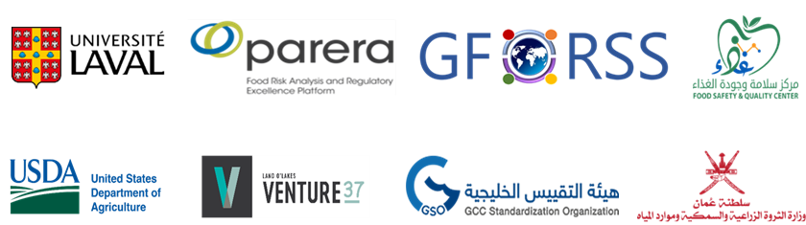
THE 2ND ARAB CODEX COLLOQUIUM
Session 3 Facilitated Discussions, Day 1: 10 June 2023
Discussion Concerning Aspirations of the Arab Region from its Participation in Codex
This session aims to have a free discussion with the Chair of the Codex Alimentarius Commission regarding what Codex Contact Points / codex Programs in the Arab Region aspire to achieve by contributing to the international food standards setting system.
- How can Codex Standards be more relevant for the Arab Region?
Click or tap here to enter text.
- How can we strengthen the leadership of the Arab Region in Codex related activities?
Click or tap here to enter text.
- What type of agenda items would you consider useful to introduce to CCNE11 ?
Click or tap here to enter text.

