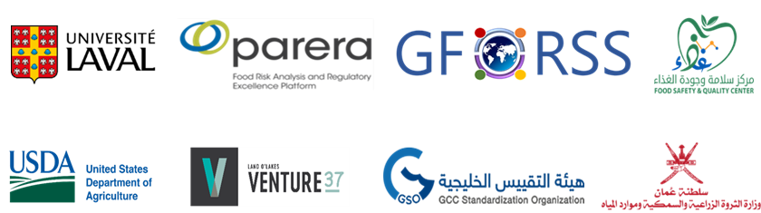
THE 2ND ARAB CODEX COLLOQUIUM
Session 1 Facilitated Discussions, Day 1: 10 June 2023
Question 1
In reviewing the accomplishments of the Arab Codex Initiative, rank the importance of these 3 key activities:
- Select Analysis of Agenda Items
- Select Coordination Meetings
- Select Support to Codex Meeting Participants
Question 2
Discuss activities / initiatives you would like the Arab Codex Initiative to do / offer.
MORE OF:  ☐ Training  ☐ Webinars on food safety topics  ☐ Coordinated participation to electronic working groups (EWG)  ☐ Monitoring activities | LESS OF:  ☐ Training  ☐ Webinars on food safety topics  ☐ Coordinated participation to electronic working groups (EWG)  ☐ Monitoring activities
Other Activities, please specify:
Click or tap here to enter text.
Question 3
Review the importance of Codex Committees that you wish the Arab codex Initiative could address more through preparation / participation in electronic working groups and enhanced engagement.
Click or tap here to enter text.

