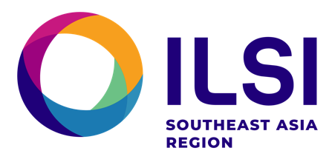
CODEX ROUNDTABLE FOR SOUTH-EAST ASIA

Proposed Terms of Reference

The Codex Roundtable for South East Asia is an informal codex coordination forum, gathering Codex Contact points of countries of South East Asia, including but not limited to countries of the Association of South East Asian Countries.

Objective:
To enhance effective participation of Codex teams of countries of South-East Asia, through increased coordination, information exchange, work-sharing opportunities and mutualization of resources

Proposed Approach:

Codex Roundtable meetings will be organized to support:
- Preparation for effective participation in Codex meetings, including the Codex Alimentarius Commission and those of the various technical committees,
- Development of data, scientific information from countries of South-East Asia, supporting Codex standard setting processes and reflecting the region’s realities
- Coordination of worksharing opportunities in support of participation in Codex technical committee discussions
- Identification of capacity building needs and delivery of training, awareness raising and competency enhancement programs destined to experts from the region, with the aim to strengthen the scientific capacity underpinning Codex programs in the region
- Development of a sustained pool of experts from the region in all areas pertaining to Codex standard setting and with emphasis on food risk analysis
- Coordination of engagement with other Codex delegations from Asia and other regions, as may be required

The Codex Rountable for South East Asia also aims to be an informal Platform that fosters the implementation of collaborative projects supporting Codex Programs in South East Asia in a sustainable fashion.

Scope

Programs and activities related to Codex Standard Setting and particiption of delegations of countries of South East Asia in these activities, including their stakeholders.

Contributors / Participants
All Codex contact points of South East Asia and individuals/organisations identified by the Codex Contact Points (CCPs) as partners and contributors to Codex Programs in these countries may contribute to the Codex Roundtable for South East Asia

Model of Operation / Values
The Codex Roundtable for South East Asia is an informal mechanism of collaboration. Participation in the Roundtable, although coordinated by Codex contact points from the region, is voluntary and does not create any formal or legal obligation to Codex contact points and the organisations with which they are affiliated.

Values pursued in conducting work under the Codex Rountable for South-East Asia are those embraced by Codex: Inclusiveness, Collaboration, Consensus Building and Transparency.

Operations and Resources
The Codex Roundatable for South East Asia will be supported by the Asia Codex Initiative, a capacity building program aiming to enhance Codex capacities in Asia, funded by the US Codex Office and implemented by the Global Food Regulatory Science Society (GFoRSS) and Landolakes Venture 37, in partnership with ILSI South-East Asia Region and Codex Contact Points of countries of South East Asia.

Key Resource Persons
A developing list of experts will support the planning, coordination and implementation of the Codex Roundtable for South-East Asia. These experts are to be identified by CCPs of the region.
This list will be regularly updated as experts join the group.

