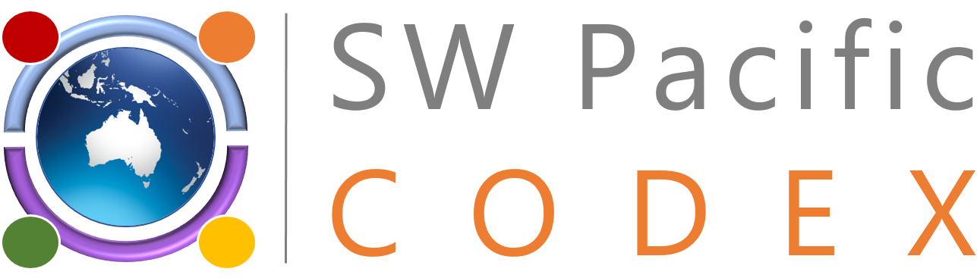
CODEX TRAINING AND OUTREACH PROGRAM DESTINED TO
SOUTH WEST PACIFIC CODEX CONTACT POINTS
Best Practices for Participation in Codex Meetings

8 – 9 November 2022
Movenpick Hotel Auckland
Auckland, New-Zealand

Facilitated Discussions SWOT Analysis
This section of the Program will be handled in the form of Roundtable discussions.
The aim is to map current Codex Capacities in SWP Countries and identify:

Strengths,
Weaknesses,
Opportunities and
Threats

Small groups will be formed, based on the seating arrangements to discuss these aspects. Each group will nominate a Spokesperson, to report on the outputs of the discussions of the group.
Strengths
Identify what you consider are the main assets that your jurisdiction has to enable your participation in Codex Proceedings.
Include strengths stemming from collective work and collaboration between SWP countries.
Click or tap here to enter text.

Weaknesses
Identify weaknesses and limitations that may impact negatively or impede your contributions to the international standard setting process under Codex, including the limitations related to : capacity, funding, limited awareness of senior management of the importance of Codex, as well as the limitations that may be encountered in using or adapting Codex standards and guidelines to support the development and enhancement of your country’s food control system.
Click or tap here to enter text.

Opportunities
Discuss opportunities that you have identified, and which may offer solutions to the current limitations to your effective participation in Codex Proceedings.
What do you see as means that may turn challenges into solutions?
Click or tap here to enter text.

Threats:
What are the predicted and possible unforeseen issues that you think you may encounter and that could constitute threats to the progress you may be accomplishing towards a stronger participation and a more effective contribution to food international standard setting.
Click or tap here to enter text.

