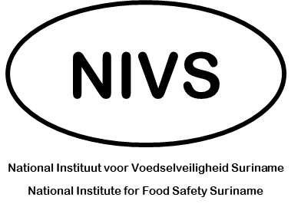
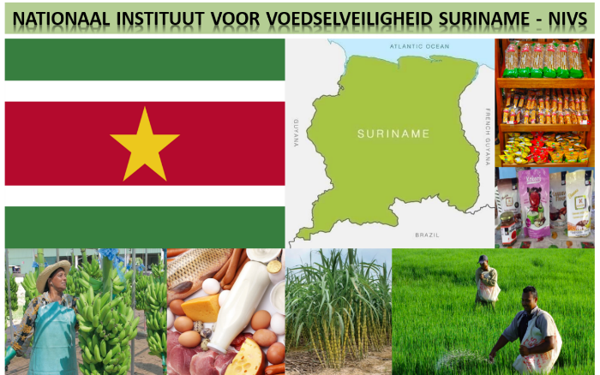
OUTPUTS OF DAY 2 DISCUSSIONS

12 – 14 August 2022

Organizational Independence
Aim to preserve independence of the organization:
- Strive to achieve financial independence.
- Item to re-examine at a later stage:
  - Change in requirements associated with the health fitness examination of food handlers – in particular, the testing requirements associated with food pathogens in physiological fluids.

Discussion of Prioritization of NIVS Areas of Work
- Sectors where Intervention would be considered a Priority:
  - Processed food sector.
  - Export-driven fruit and vegetable sector.
  - Imported food sector.
At a later stage address:
  - Domestic meat and poultry / dairy sector.
  - Restaurant / caterers.
  - Street vendors.
- Food Regulatory Interventions to Operationalize
  - Registration: identification of Food Business Operations (FBOs).
Identification of FBOs through other government authority registration systems and associations.
  - Legislative review of various food statutes and development of new legislation.
  - Development of new food import regulations.
  - Standard setting function:
- List of authorized pesticides → MRLs.
- Pesticide board?
  - Food labelling requirements: this area would address consumer’s interest.
  - Contaminants in food.
- Human Resources Strategy
  - Need salary level that supports the attraction and retention of young talent.
  - Consider engagement with technical college, food science / safety.
  - Possible development of e-training curriculum / training that would support selection of candidates.
  - Leverage VKI inspector capacity for identification of inspectors.
  - Develop competency-based development for HR.
- Infrastructure Aspects
  - Initial installation – Prefab – in area close to VKI HQ.
  - Longer term: identify loan / donor source for the construction of a permanent HQ.

