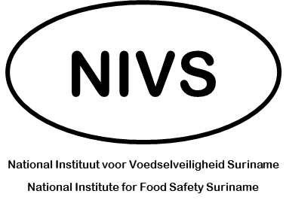
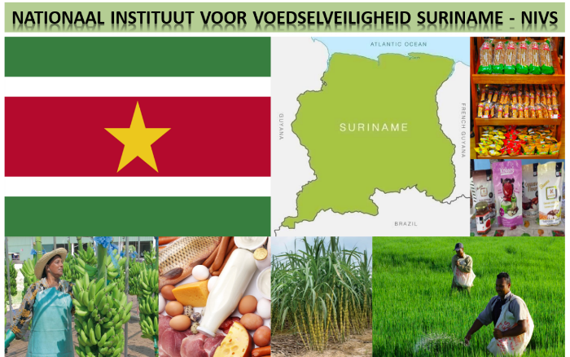
OUTPUTS OF DAY 1 DISCUSSIONS

12 – 14 August 2022

Values
- Consensus Driven.
- Openness.
- Practical.

Indicators of NIVS Success
- Updated food safety legislation.
- Recognition at the national level and international level (regional level).
- Raising stakeholder awareness: supporting ownership of food safety by the private sector.
- Regulations supporting safer food.
- Food safety environment in Suriname: Food from Suriname is Trusted!
- Better food labelling.
- Better manufacturing practice = better observance of GMP, storage, etc.
- Responsiveness of NIVS to concerns from consumers and industry.
- Availability of certification systems for local products.
- Increased trust in exported agri-food products.
- Fully staffed organization.
- Enhanced fairness between industry players: creating level playing field.
- Fairness / predictability.
- Industry feels safe.
- Better knowledge of food safety throughout.
- Maintain / preserve independence.

Principles of Operationalization
- Leveraging VKI capacities.
- Adaptation to specificities of the sector.
- Create incentives for stakeholders / regulated parties to embrace organization.
- Support attaining requirements of big buyers – e.g., certification – for some suppliers – e.g. ISO 48001.
- Offer dedicated laboratory services.

What we Need to Accomplish in Less than 6 Months
- Staff: at least 3 staff supporting implementation, as part of Agriculture Competitiveness Program.
- In 6 months: pesticide analysis for crops offered by NIVS laboratory as a paid service to stakeholders.
- Exercise oversight on all food safety investments, including from SAMAP, to ensure cohesiveness.
- Organize Donor Roundtable to support further investments upon availability of a strategic plan and rollout plan.

