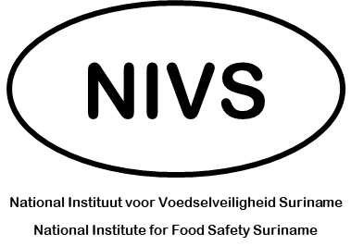
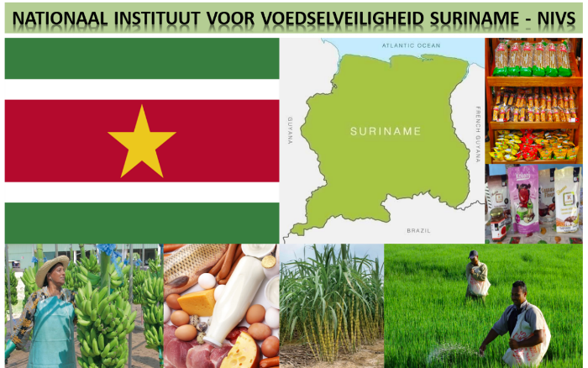
DISCUSSION POINTS
Output of Prioritization
12 – 14 August 2022

Question 2

Rank | % Importance | Indicator
1 | 93% | NIVS key positions supporting food regulatory functions staffed and operational.
2 | 87% | Food Business Operations known to NIVS and registered with high level of traceability of who does what in Suriname.
3 | 85% | A clear decision-making process for NIVS established – i.e.: a clear system for regulations development adopted and applied.
4 | 82% | New regulations and food regulatory decisions promulgated by NIVS.
5 | 79% | A stakeholder outreach forum gathering the stakeholder community designed to identify priorities and to design programs that serve the needs of the country and sector.
6 | 79% | A new legislation for food and food safety in Suriname developed.
7 | 76% | A science capacity for NVIS setup and operational – i.e.: a food testing operation supporting NIVS and the food sector fully operational; a food risk assessment capacity supporting decision-making.
8 | 75% | A website featuring NIVS as the primary food safety regulator operational, featuring NIVS and its activities.
9 | 73% | International visibility: NIVS recognized among its peer food regulatory organizations.
10 | 72% | New resources for food safety practices available to Industry – i.e.: educational material, guidance, etc.

