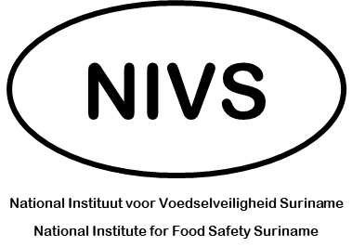
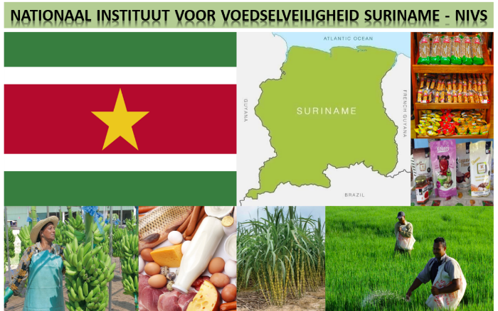
DISCUSSION POINTS
Principles of NIVS Operationalization
12 – 14 August 2022

Background
NIVS is entrusted to rebuild the food (safety) regulatory oversight from the ground up.
NIVS is however based on a Surinamese experience: the creation and operationalization of the fisheries Inspection Institute (VKI).
Options to operationalize NIVS may consider leveraging the capacity of VKI and moving forward to enhance it / extend its reach to other sectors.

Discussion Points
- Discuss the strengths and features of VKI that you would like / consider important to see replicated in NIVS?
Click or tap here to enter text.

- Discuss where / how you would like the following capacities to be extended to NIVS:
- Availability of web presence.
- Registration of establishments.
- Inspection system.
- Rule-making and standard setting capacity.
- Other key features that you would like to see extended and/or developed.
Click or tap here to enter text.

- Discuss values that you would like to see NIVS espouse as a food regulator.
Click or tap here to enter text.

