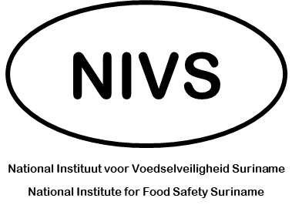
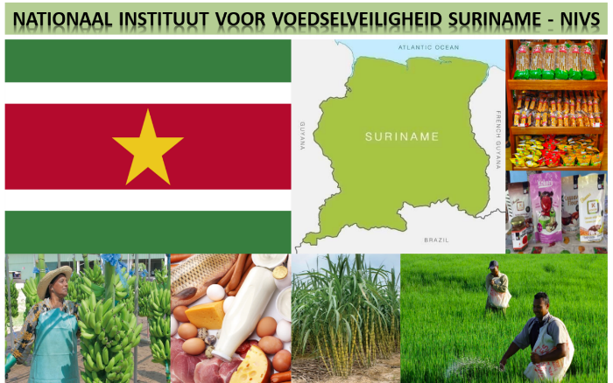
DISCUSSION POINTS
Prioritizing Horizontal
Regulatory Functions
12 – 14 August 2022

Discussion Points
- Discuss the priority of developing a new food legislation for Suriname and what you would like to see the Regulation encompass.
Click or tap here to enter text.

- What are the priorities of horizontal food standard setting?
Rank from 1 to 10 with 1 being less important and 10 being very important.

Rank | Priority
Requirements / Rules
 | Additives
 | Contaminants
 | Pesticides
 | Veterinary Drugs
 | Incidental Additives
 | Novel Foods
 | Microbiological Criteria
 | Labelling, in general
 | Nutrition Labelling
 | Allergen Labelling
 | Compulsory Testing Methods
Management of Establishments
 | Registration / Licensing
 | Pre-Requisite Programs
 | Preventive Controls
 | Good Agricultural Practice (GAP)
 | Traceability Requirements

- What are the incident management functions that you would like to see NIVS adopt as a priority?
Rank from 1 to 10 with 1 being less important and 10 being very important.
Rank | Priority
 | Food Safety Investigation
 | Food Recall Capacity
 | Early Warning System
 | Rapid Risk Assessment Capacity

- Discuss early areas of implementation of the horizontal rule-making function.
Click or tap here to enter text.

- Discuss the sectors where you would consider these rules should apply first.
Click or tap here to enter text.

