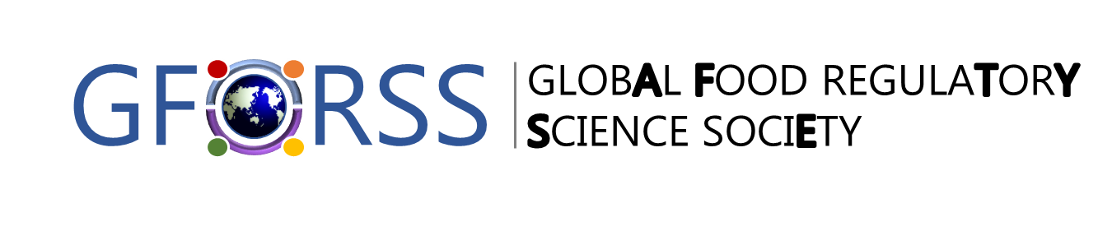
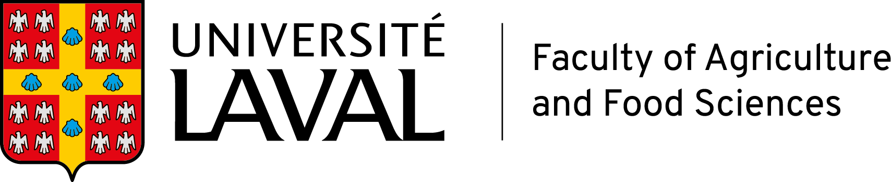

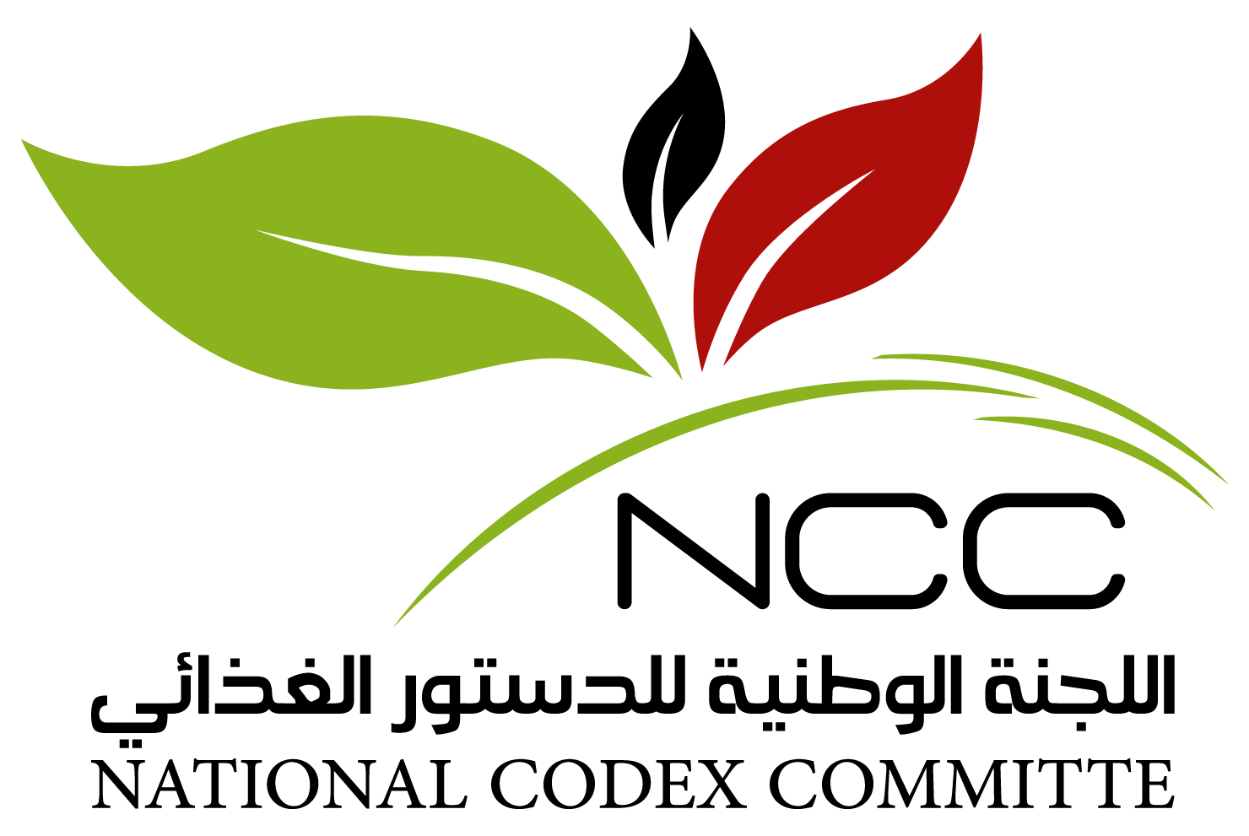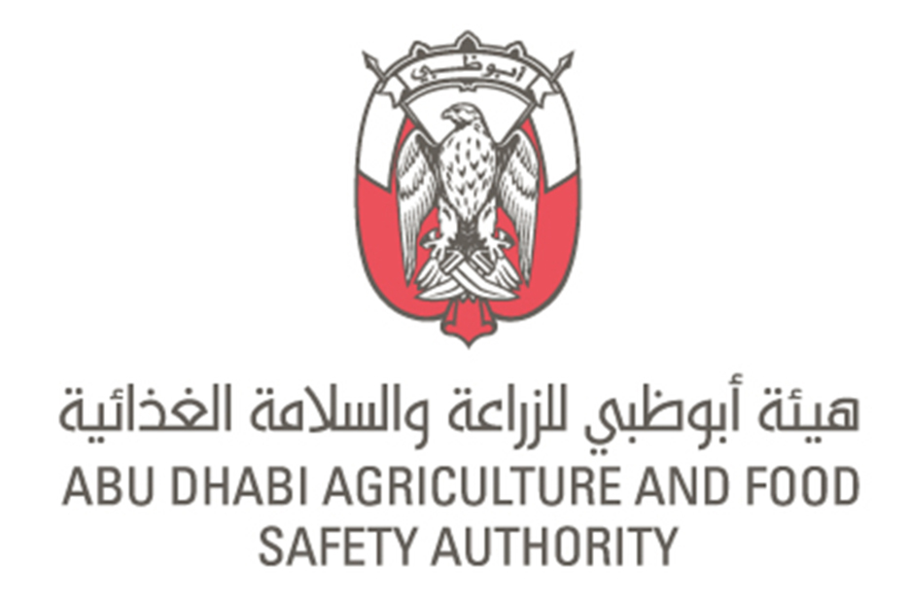
CODEX COLLOQUIUM FOR THE MIDDLE EAST AND NORTH AFRICA REGION
12-14 September 2021
JW Marriott Marquis, Dubai, United Arab Emirates
Session 3: Reviewing Recent Developments Achieved by Codex Technical Committees and Impacts on Food Regulatory Initiatives in the MENA Region
Codex Committee on Contaminants in Food (CCCF) – Review of Outputs
12 September 2021, Emirates Ballroom 5 & 6
Challenges of Participation in CCRVDF Proceedings?
This facilitated discussion aims to capture:
- The current challenges that CCRVDF has been facing over the past period in relation with some agenda items e.g. Halquinol, Zilpaterol
- Your analysis of the root causes associated with these challenges in moving some standards forward
- Your proposals to address these challenges and enable an easier management of the CCRVDF agenda that serves the Codex Mandate

Your opinion as to the Root-causes for the current polarization of opinions related to the CCRVDF agenda and the fact that some standards are not proceeding with the expected timelines.
Please capture information collected from delegates seated at your table:

- Why do think this polarization is occurring for the relevant agenda items
Click or tap here to enter text.

- What can be done / should be done to address these challenges and enable a smoother management of standards within the mandate of CCRVDF?
Click or tap here to enter text.

