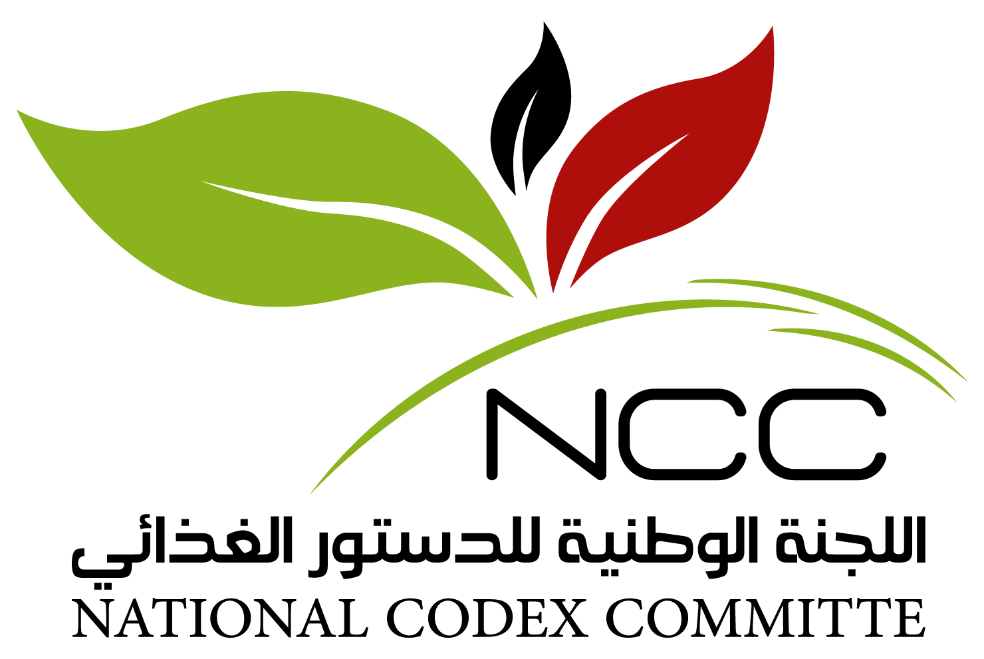
CODEX COLLOQUIUM FOR THE MIDDLE EAST AND NORTH AFRICA REGION
12-14 September 2021
JW Marriott Marquis, Dubai, United Arab Emirates
Session 3: Reviewing Recent Developments Achieved by Codex Technical Committees and Impacts on Food Regulatory Initiatives in the MENA Region
Codex Committee on Contaminants in Food (CCCF) – Review of Outputs
12 September 2021, Emirates Ballroom 5 & 6
How can we bolster participation in CCCF?
This facilitated discussion aims to capture:
i) the current level of participation in CCCF from the Middle East and North Africa (MENA) region.
ii) The CCCF standards that present an issue in the MENA Region.
iii) Prioritization of the main concerned CCCF standards for the MENA Region.
iv) Availability of the data from the region needed for standards under preparation and new work.

Documenting Level of CCCF participation
Please capture information collected from delegates seated at your table:
- Does your country consider CCCF as a priority codex committee and explain why?
Yes or No. Explanation.
Click or tap here to enter text.
- Which E-Working Group is of high relevance and would require your country’s participation and why?
e-working group of high relevance / Justification.
Click or tap here to enter text.

Accessing Data Relevant to the Contribution of MENA Codex Delegations in on-going CCCF Work/New Work:
Please capture information collected from delegates seated at your table:
- Discuss availability of data; accessibility and ability to share such data for the purposes of submission to the GEMS/Food Program, including impediments and challenges and the way to overcome them for the following contaminants/ commodities:
- Lead in various food products with a focus on: tea/herbal teas, cereal and cereal products (including infant food), fruit juices, sugar and sugar-based candies, spices, Quinoa….
- Aflatoxins (AFL) in cereals and cereal-based products; ready to eat peanuts, spices
- Ochratoxin A in spices
The discussion could cover:
- Existing data available from your institution or a collaborating institution
- Existing data captured in the published peer-reviewed literature
- New data to be generated through research and data collection (e.g. monitoring initiatives)
Click or tap here to enter text.

