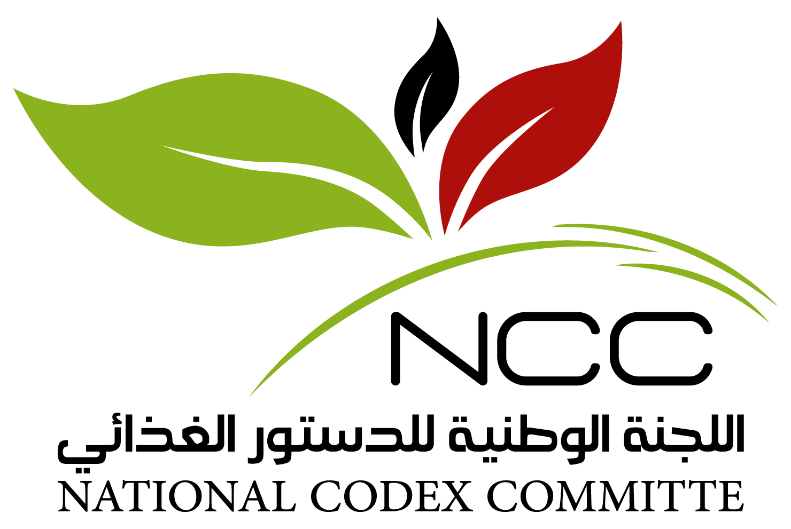
CODEX COLLOQUIUM FOR THE MIDDLE EAST AND NORTH AFRICA REGION
12-14 September 2021
JW Marriott Marquis, Dubai, United Arab Emirates
Session 2: Setting the Stage – Workshop Expectations, Current Status of
Codex Participation from the Region
12 September 2021, Emirates Ballroom 5 & 6
How can we bolster participation in Codex proceedings?
This facilitated discussion aims to capture the current level of participation in Codex Committees from the Middle East and North Africa (MENA) region.
It will attempt to document current challenges faced by Codex teams in the region, preventing / limiting participation in and effective preparation for Codex Committees.

Documenting Level of Participation
Please capture information collected from delegates seated at your table:
- Which Codex Committee(s) have your Country participated in during 2021?
Country → Codex Committee(s)
Click or tap here to enter text.
- How different was your participation pre-pandemic, i.e. in comparison to the period before 2019?
Pre-2019: Country → Codex Committee(s)
Click or tap here to enter text.

Documenting Priorities of Codex Committees
Please capture information collected from delegates seated at your table:
- Discuss, at your table, what are the top 5 Codex Committees that your country consider as high priority warranting participation and contribution. Explain why. For example:
- Strategic importance for national standard development.
- Strategic importance for import / export control.
- Importance related to market access considerations.
- Importance related to interest in leveraging Codex resources for national standard development.
- Etc.
Click or tap here to enter text.

Challenges and Enablers Related to Participation in Codex Proceedings
Discuss the key challenges that impede your country’s:
- Participation in Codex meetings.
- Effective preparation for Codex proceedings – electronic working groups / committees.
- Participation in coordination committees at the regional level – within the MENA region – and with other delegations beyond the region.
Click or tap here to enter text.

Possible Solutions and Enablers
Discuss at your table and record what you consider as enablers / solutions to address the challenges and impediments identified above.
Click or tap here to enter text.

