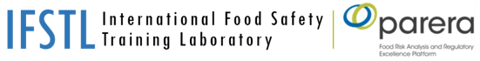

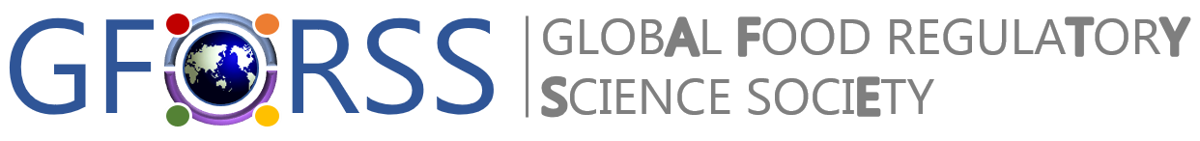

https://r-biopharm.com/wp-content/uploads/logo_rgb-2.png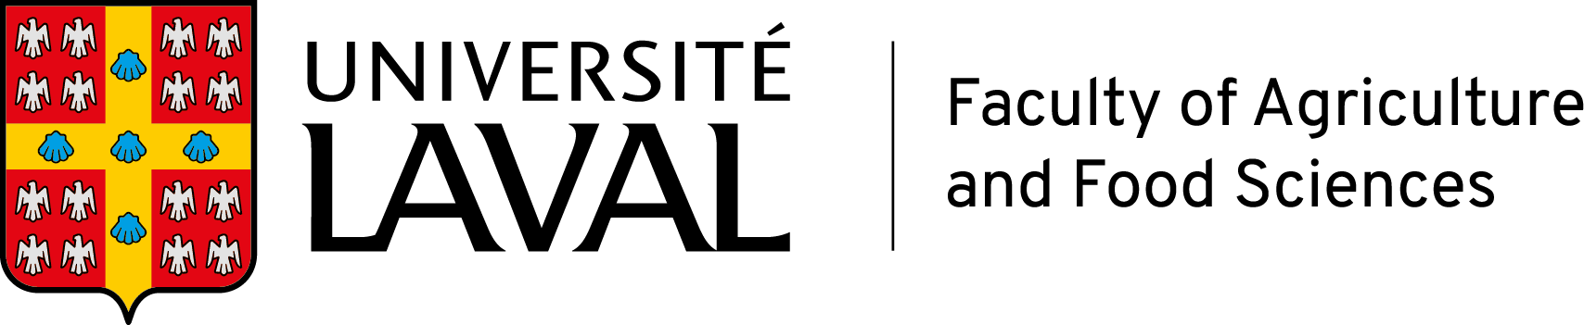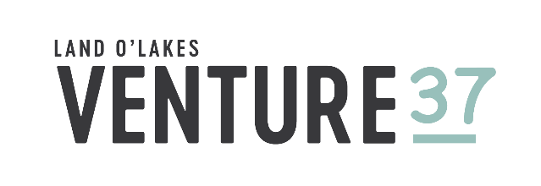

**VIRTUAL WORKSHOP**

***Workshop on Rapid Methodologies for Mycotoxin Analysis and Control***

Webinar through Zoom Platform | 22 June, 2021 from 9:30 – 11:30 Cairo Time (UTC +2)

**Background**

Mycotoxins are priority food contaminants impacting the food supply from primary production to processed foods. Staple foods and strategic agri-food commodities for Egypt and other nations such as cereal and cereal-based products are impacted by occurrence of mycotoxins in these commodities, which makes them subject to control at various stages of food production.

Rapid analytical methods offer the opportunity to support mycotoxin control measures through early identification and screening of the thousands of samples that may be subjected to safety and quality controls as well as regulatory oversight to ensure that raw material and supply received by countries, large buyers and traders for products sources domestically or traded internationally.

Considering the current changes that the Arab Republic of Egypt is contemplating in transforming the regulatory requirements associated with contaminants in food, it is important to enable access to various food and feed analytical strategies that respond to the needs of testing in the context of compliance verification and quality / safety controls.

This workshop aims to offer an overview of the current techniques made available for rapid screening of mycotoxins in food and feed commodities, using immunochemical methods. It will discuss fit for purpose, validation requirements and perspective of application in rapid screening and in-field testing.

The workshop is to be offered to food regulatory staff of the National Food Safety Authority of Egypt (NFSA), to its partners and stakeholders involved in controlling, testing and managing mycotoxin control in targeted commodities used in food / feed production.

|  |  |
| --- | --- |
| PROPOSED AGENDA  *22June 2021 from 9:30 – 11:30 AM Cairo Time (UTC +2)* | |
| 30 minutes | **Introduction – Objectives of Session and Context**  Positioning current efforts of food contaminants management and importance of analytical methods-  *Prof. Samuel Godefroy, Université Laval, Québec, Canada* |
| 30 minutes | **Introduction to Mycotoxin Testing Requirements and Methods Available for Rapid Screening**  *Dr. Carrie Maune, Trilogy Laboratories (Largest US Mycotoxin testing laboratory in the United States)* |
| 30 minutes | **Mycotoxins - Rapid Testing Solutions**  *Kai Pumpa, Product Manager Mycotoxins, Food & Feed Analysis, R-Biopharm AG* |
| 30 minutes | **Questions and Answers** |

**About the Global Food Regulatory Science Society (GFoRSS)**

[GFoRSS](http://www.gforss.org/) is a not-for-profit organization hosted by the Food Risk Analysis and Regulatory Excellence Platform ([PARERA](https://parera.ulaval.ca/)) of Laval University’s Department of Food Science and the Institute of Nutrition and Functional Foods.

The Society aims to promote the generation and dissemination of knowledge and competencies related to food regulatory sciences, that is, all disciplines applied in the context of developing, implementing and evaluating food regulatory decisions including, but not limited to, food risk analysis and associated disciplines.

Membership consists of scientists and regulators from food regulatory agencies at any level of government: municipal, state / provincial, national and international, including international organizations, scientists and professionals in any related food regulatory scientific discipline from non-governmental organizations and academic institutions.